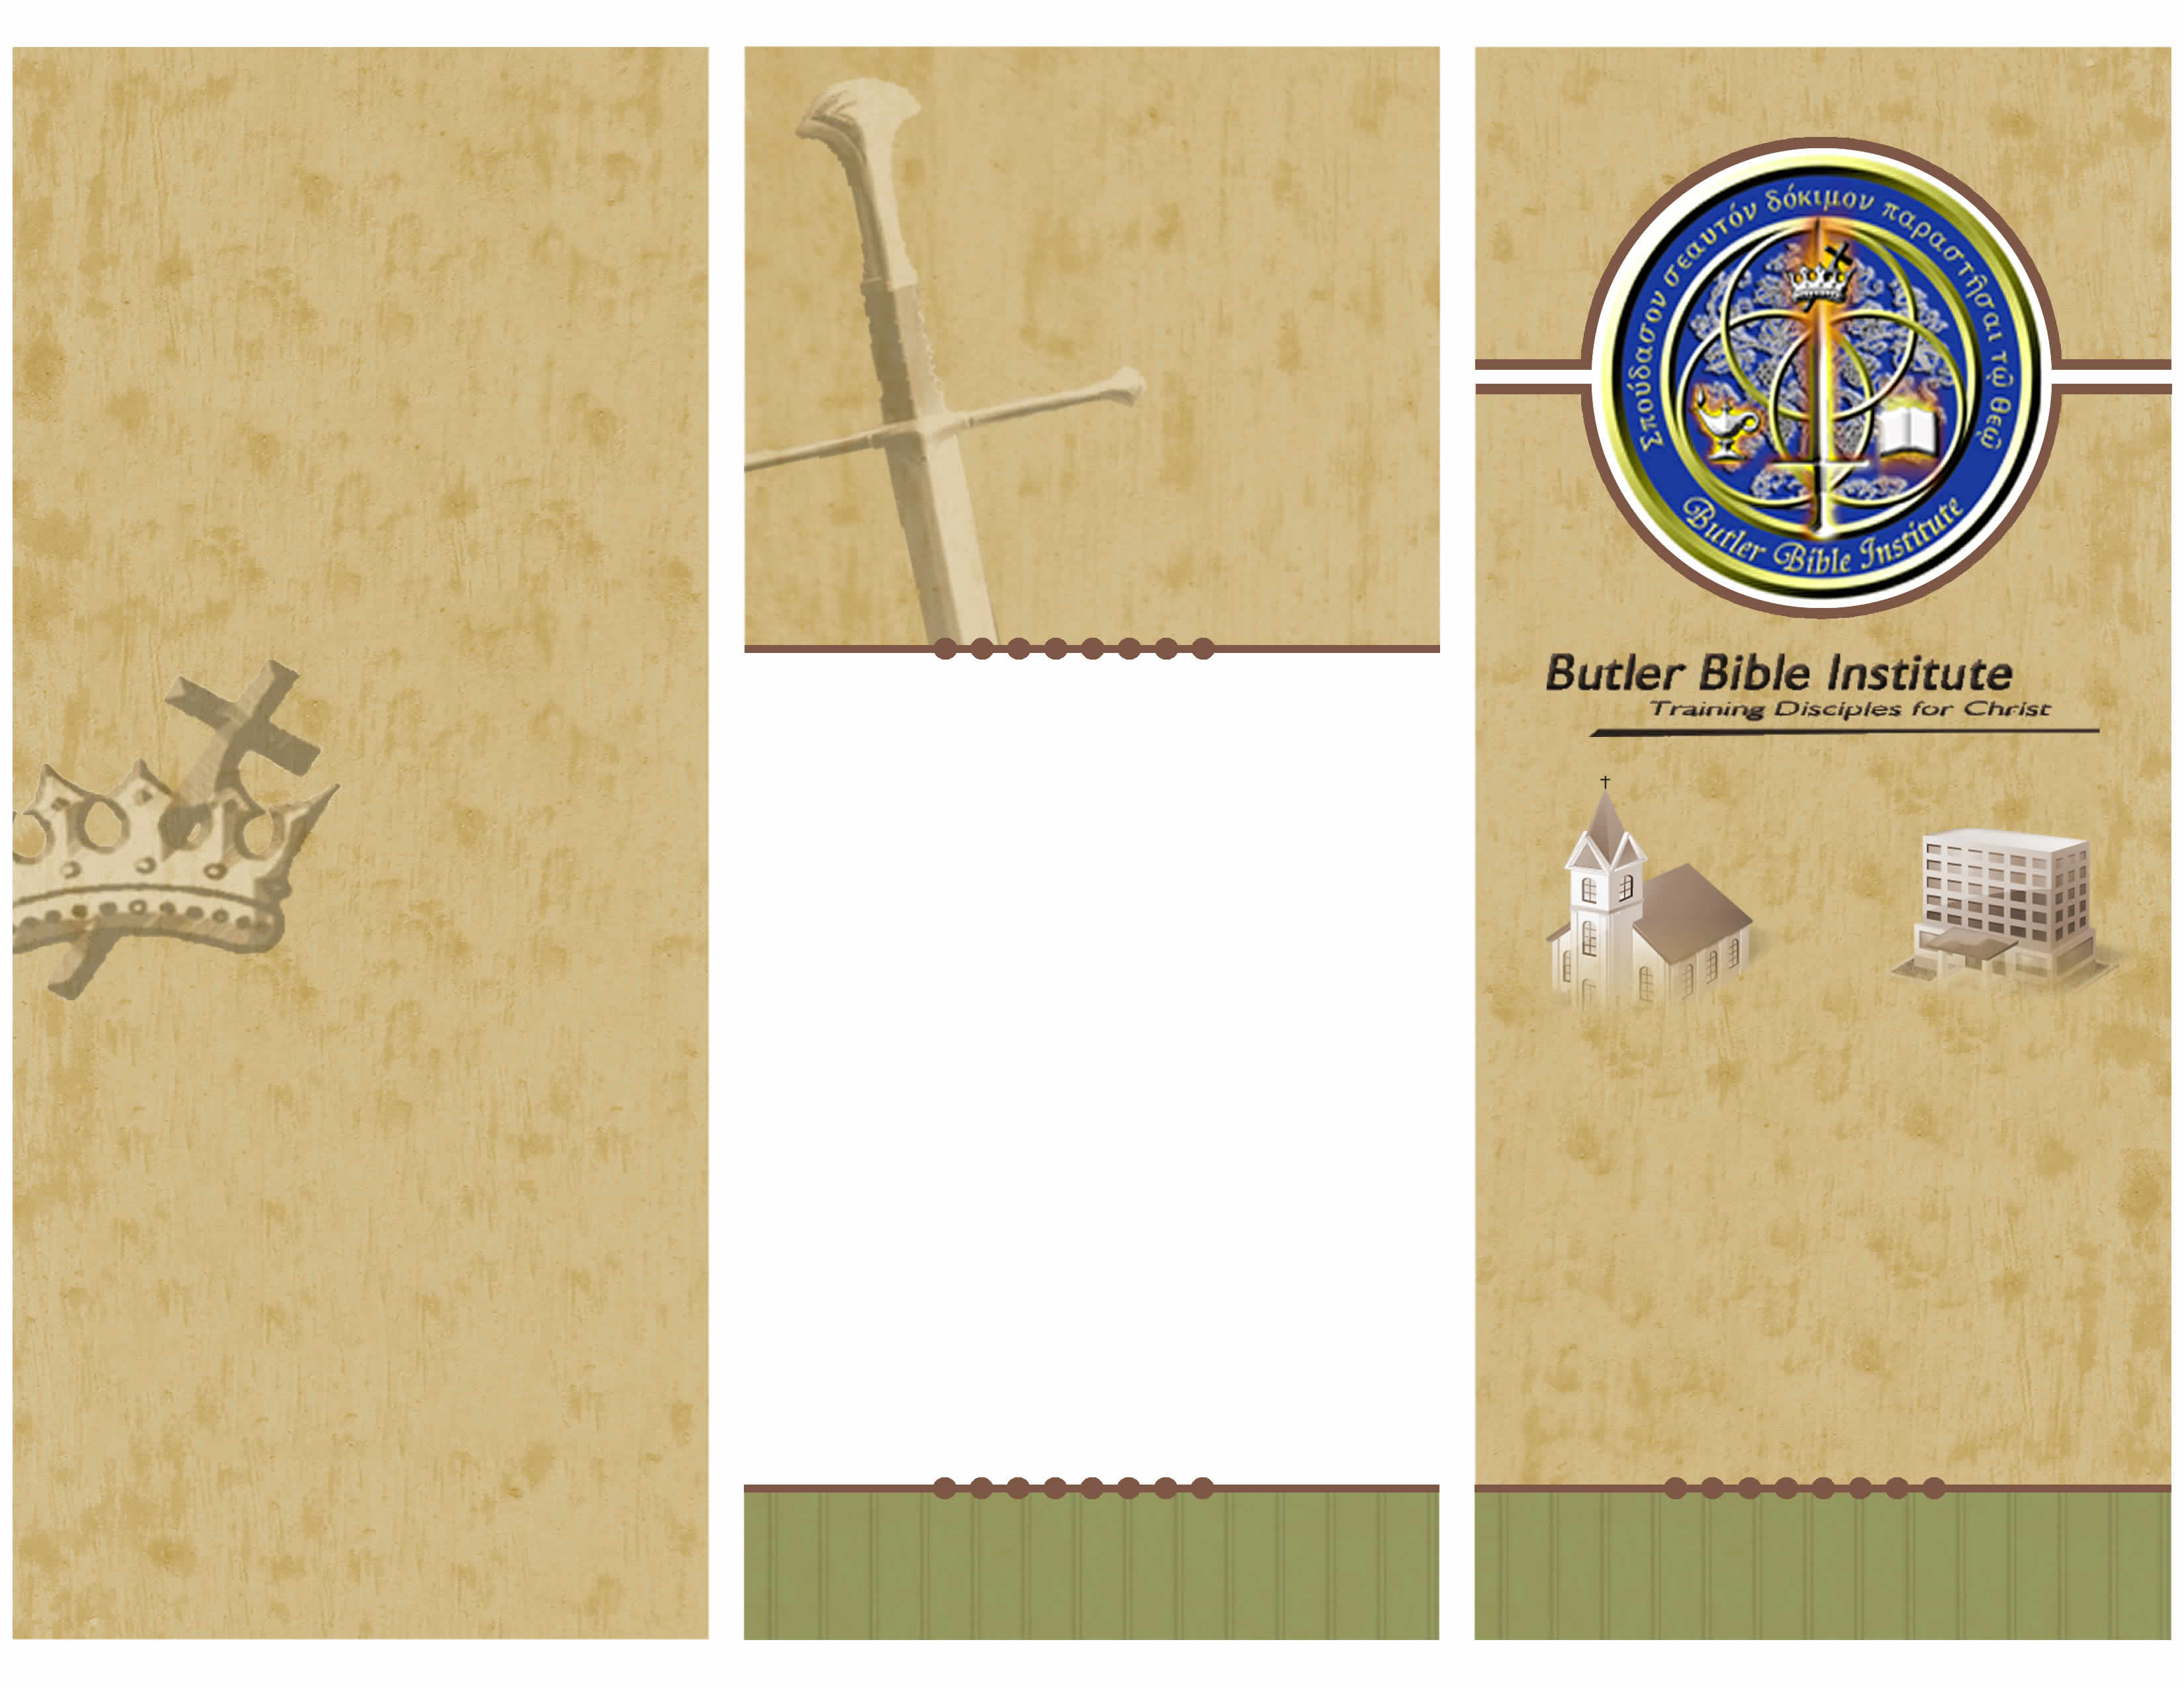
Sanctification

We teach that every believer is sanctified (set apart) unto God by justification and is therefore declared to be holy and is therefore identified as a saint. This sanctification is positional and instantaneous and should not be confused with progressive sanctification.

Security

We teach that all the redeemed once saved are kept by God’s power and are thus secure in Christ forever (John 5:24; 6:37-40; 10 : 27~30; Romans 5:9- 10; 8: I, 31-39; 1 Corinthians 1 : 4~8 ;Ephesians 4:30; Hebrews 7:25; 13:5; I Peter I:5; Jude 24).

Separation

We teach that separation from sin is clearly called for throughout the Old and New Testaments, and that the Scriptures clearly indicate that in the last days apostasy and worldliness shall increase (2 Corinthians 4: 14-7: I; 2 Timothy 3: 1-5).

The Church

We teach that all who place their faith in Jesus Christ are immediately placed by the Holy Spirit into one united spiritual body, the church (I Corinthians 12:12-13), the bride of Christ (2 Corinthians 11 :2; Ephesians 5:23-32; Revelation 19:7-8), of which Christ is the head (Ephesians 1:22; 4:15; Colossians I:18).

Angels

We teach that angels are created beings and are therefore not to be worshiped. Although they are a higher order of creation than man, they are created to serve God and to worship Him (Luke 2:9-14; Hebrews 1:6-7, 14; 2:6-7; Revelation 5:11-14; 22:9).
Fallen Angels

We teach that Satan is a created angel and the author of sin. He incurred the judgment of God by rebelling against his Creator (Isaiah 14: 12-17; Ezekiel 28: 11- 19), by taking numerous angels with him in his fall (Matthew 25:4 I; Revelation 12:1-14), and by introducing sin into the human race by his temptation of Eve (Genesis 3:1-15).

Death

We teach that physical death involves no loss of our immaterial consciousness (Revelation 6:9-11), that the soul of the redeemed passes immediately into the presence of Christ (Luke 23:43).

Required Courses for Certificate or Diploma | Units
Practical Ministry Experience | 4
Biblical Theology 1: Theology of God | 2
Biblical Theology 2: Theology of the Bible | 2
Biblical Theology 3: Theology of the Church | 2
Biblical Theology 4: Theology of Salvation | 2
Biblical Theology 5: Nation of Israel | 1
Biblical Studies 1: Old Testament Survey | 2
Biblical Studies 2: New Testament Survey | 2
Biblical Studies 3: Book of Genesis, Ch.1-11 | 2
Biblical Studies 4: Book of John | 1
Biblical Studies 5: Book of Romans | 2
MP 1 – Missions & Evangelism | 2
MP 2 – Hermeneutics | 1
Elective courses: | 5
Total: | 30

Classroom Location:

North Street Christian Church
220 W. North St.
Butler, PA 16001
Business Office:

Butler Bible Institute
348 Holyoke Road
Butler, PA 16001

Note:
“Certificate” is awarded to those who have less than a 4-year college degree;
“Diploma” is awarded to those having a 4-year college degree or higher.
(724) 283 – 3413
info@ButlerBibleInstitute.org
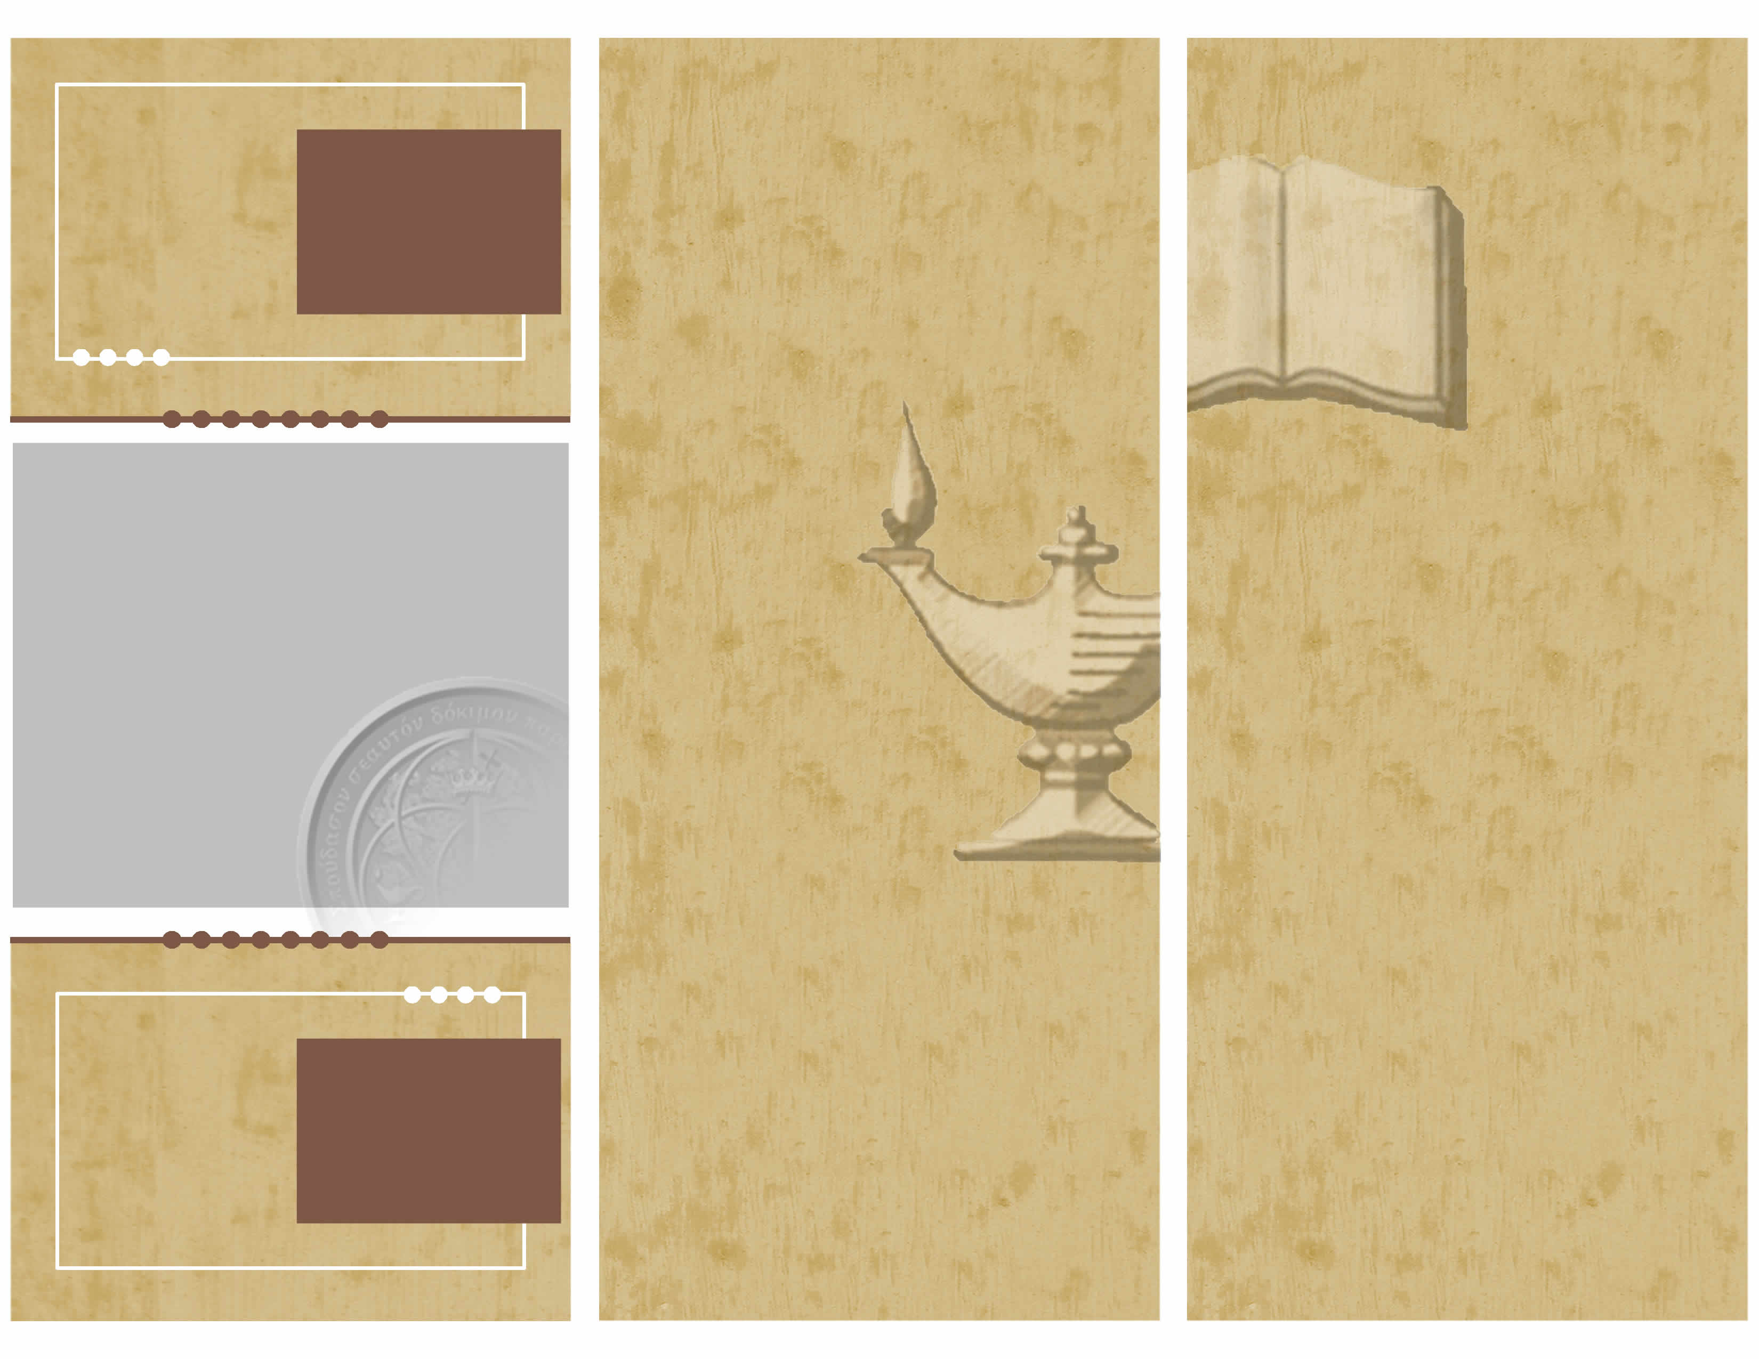
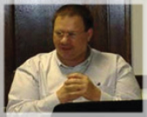
Pastor Bob Huber, Senior Pastor

BA in Bible - Johnson Bible College, Knoxville, TN.
The Holy Scriptures

We teach that the Bible is God’s written revelation to man, and thus the sixty- six books of the Bible given to us by the Holy Spirit constitute the plenary Word of God (I Corinthians 2:7-14; 2 Peter 1:20-21). We teach that the Word of God is an objective, propositional revelation (I Thessalonians 2:13).

God

We teach that there is but one living and true God (Deuteronomy 6:4; Isaiah 45 :5-7; 1 Corinthians 8:4), an infinite, all-knowing Spirit (John 4:24), perfect in all His attributes, one in essence, eternally existing in three Persons-Father, Son, and Holy Spirit (Matthew 28: 19; 2 Corinthians 13: 14) each equally deserving worship and obedience.

God the Father

We teach that God the Father, the first person of the Trinity, orders and disposes all things according to His own purpose and grace (Psalm 145:8-9; I Corinthians 8:6). He is the creator of all things (Genesis 1: 1-3, Ephesians 3:9). As the only absolute and omnipotent ruler in the universe, He is sovereign in creation, providence, and redemption (Psalm 103).

God the Son

We teach that Jesus Christ, the second person of the Trinity, possesses all the divine attributes, and in these He is coequal, consubstantial, and coeternal with the Father (John 10:30).

God the Holy Spirit

We teach that the Holy Spirit is a divine person, eternal, and possessing all the attributes of personality and deity including intellect (I Corinthians 2:10-13), emotions (Ephesians 4:30), will (I Corinthians 12: 11), eternal existence (Hebrews 9: 14), and omnipresence (Psalms 139:7-10), omniscience (Isaiah 40: 13- 14), omnipotence (Romans 15: 13), and truthfulness (John 16:13).
Man

We teach that man was directly and immediately created by God in His image and likeness. Man was created free of sin with a rational nature, intelligence, volition, self-determination, and moral responsibility to God (Genesis 2:7. 15-25; James 3:9).

Salvation

We teach that salvation is wholly of God by grace on the basis of the redemption of Jesus Christ, the merit of His shed blood, and not on the basis of human merit or works (John 1:12, Ephesians 1:7, 2:8-10, I Pet. 1:18-19).

Regeneration

We teach that regeneration is a supernatural work of the Holy Spirit by which the divine nature and divine life are given (John 3:3-7; Titus 3:5). It is instantaneous and is accomplished solely by the power of the Holy Spirit through the Word of God (John 5:24), when the repentant sinner, as enabled by the Holy Spirit, responds in faith to the divine provision of salvation.

Election

We teach that election is the act of God by which, before the foundation of the world, He chose in Christ those whom He graciously regenerates, saves, and sanctities (Romans 8:28-30; Ephesians 1 :4- 11; 2 Thessalonians 2: 13; 2 Timothy 2:10; I Peter 1:1-2).

Justification

We teach that justification before God is an act of God (Romans 8:33) by which He declares righteous those who, through faith in Christ, repent of their sins (Isaiah 55 :6-7; Luke 13 :3; Acts 2:38; 3: 19; 11 : 18; Romans 2:4; 2 Corinthians 7: 10) and confess Him as sovereign Lord (Romans 10:9-10; I Corinthians 12:3; 2 Corinthians 4:5; Philippians 2:II).

The Butler Bible Institute was established on 1-15-2004 with the goal of supporting the local church in educating and equipping followers with a deeper theological understanding of scripture and equipping them to share and defend their faith. By providing an affordable and theologically sound education to all those who earnestly seek to know the word of God better, students are able to make a greater contribution to the Kingdom through ministry efforts in the local church and community. At the Butler Bible Institute students will find highly dedicated and qualified teachers practicing biblical fidelity in teaching sound orthodox Christian doctrine.
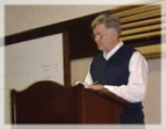
Bob Ogden, Elder & President of BBI

BSEE, MS BAd, - Virginia Tech, Blacksburg, VA.
Diploma in Theology - Theological Practorium, Mansfield, OH.

